Day 12 – Implementation

Welcome to Day #12, the last day of the course. I want to thank you for putting up with me these last 12 days. It has been an honor to serve you.

In thinking this course over I decided to add, Implementation based on the response and common questions that I was receiving from my subscribers.

How do I get started?
- Do you have a product or service that you currently sell?
- Do you have a team in place?
- What should I be doing each day?

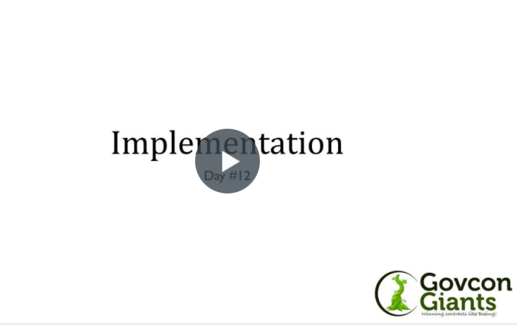

Give me my training

Today’s training will help you answer those questions and many more. We want to teach you how to effectively maximize the lessons that you’ve learned over the last 12 days.

Last call! You don’t have to go home, but you have to ….

Remember the government does not want to see you fail. Take a chance. Give it a whirl. If you underbid give the contract back. If you overbid, send me a check!!

Best of luck.
Eric Coffie

